Sri Sivasubramaniya Nadar College of Engineering,
Kalavakkam - 603 110
(An Autonomous Institution, Affiliated to Anna University, Chennai)

Course Code | UIT2702 | Course Name | Cloud and Distributed Computing
Regulation | 2021 | Academic Year | 2026-2027
Semester |  | VII
Department Offering the Course |  | Information Technology
Exercise: 02 |  | Remote Method Invocation (RMI) & Google Cloud Console Basics

Name: Rahul Akshath Rajendran
Reg No: 3122235002095
Sem / Sec: VII B

Exp. No: 02 Date: 15-07-2026
REMOTE METHOD INVOCATION (RMI) AND GOOGLE CLOUD CONSOLE BASICS
AIM
To implement Remote Method Invocation (RMI) so that the methods of an object residing on a server can be executed remotely by a client in a distributed computing setup, and to learn the basics of the Google Cloud Console by managing projects, reviewing and modifying IAM roles and enabling APIs and services.

QUESTION
Exercise 1: Remote Method Invocation (RMI)
- Define Remote Service: Create a Calculator class on the server with methods for addition and multiplication. Use Pyro4 to expose these methods for remote invocation by clients.
- Server Setup: Register the Calculator service with a Pyro4.Daemon to generate a unique URI. Start the daemon to listen for incoming client requests.
- Client Invocation: Prompt the client to input the server URI, connect via Pyro4.Proxy, and invoke the remote addition and multiplication methods. Display the results of both operations on the client side.
Exercise 2: Google Cloud Console Basics - Managing Projects, Roles and APIs
Objective: Learn how to access the Google Cloud Console, manage projects, modify IAM roles, and enable APIs.
- Task 1: Access the Google Cloud console.
- Task 2: View projects in the Cloud console.
- Task 3: Review and modify roles and permissions.
- Task 4: Enable APIs and services.

ALGORITHM / STEPS
Exercise 1 - RMI Server
1. Import the Pyro4 module, which provides remote method invocation for Python objects.
2. Define a class Calculator and mark it with the decorator @Pyro4.expose so that all its methods can be called by remote clients.
3. Inside the class define the methods add(a, b) and multiply(a, b) that return the sum and the product of the two arguments.
4. Create a Pyro4.Daemon() object; the daemon is the server that listens for remote calls.
5. Register the Calculator class with the daemon. Registration returns a unique URI of the form PYRO:obj_<id>@<host>:<port> that identifies the remote object.
6. Print the URI so that it can be copied into the client.
7. Call daemon.requestLoop() so that the server keeps waiting for and serving client requests.
Exercise 1 - RMI Client
1. Import the Pyro4 module.
2. Read the URI that was printed by the server.
3. Create a proxy object using Pyro4.Proxy(uri). The proxy acts as a local stub of the remote object.
4. Read the two numbers from the user.
5. Call calculator.add(a, b) and calculator.multiply(a, b) exactly like local method calls. Pyro4 serializes the call, sends it to the server, executes the method there and returns the result over the network.
6. Display the addition and multiplication results received from the server.
Exercise 2 - Google Cloud Console
1. Task 1: Open a browser, go to console.cloud.google.com and sign in with the given credentials. Accept the terms and conditions to reach the Cloud Console dashboard.
2. Task 2: Click the project drop-down list at the top of the console to see all the projects that are available. Select the project and note down the Project name, Project ID and Project number shown in the Project info card of the Dashboard.
3. Task 3: Open the Navigation menu and choose IAM & Admin > IAM. The page lists every principal (user or service account) along with the roles assigned to it. Use GRANT ACCESS to add a principal and assign a role (for example Viewer), or use the edit (pencil) icon to change an existing role, and click Save. IAM & Admin > Roles can be used to inspect the individual permissions that belong to a role.
4. Task 4: Open the Navigation menu and choose APIs & Services > Library. Search for the required API (for example the Cloud Storage API or the Dialogflow API), open it and click ENABLE. Verify that it now appears under APIs & Services > Enabled APIs & services.

CODE
Exercise 1 - Remote Method Invocation using Pyro4
server.py
import Pyro4

@Pyro4.expose
class Calculator:
def add(self, a, b):
return a + b
def multiply(self, a, b):
return a * b

daemon = Pyro4.Daemon()
uri = daemon.register(Calculator)
print("Server is running...")
print("URI:", uri)

daemon.requestLoop()

client.py
import Pyro4

uri = input("Enter the Server URI: ")
calculator = Pyro4.Proxy(uri)

a = int(input("Enter first number: "))
b = int(input("Enter second number: "))

print("Addition =", calculator.add(a, b))
print("Multiplication =", calculator.multiply(a, b))

Steps to execute
- Install the library once using "pip install Pyro4".
- Open two terminals. Run "python3 server.py" in the first terminal; it prints the URI of the registered remote object.
- Run "python3 client.py" in the second terminal, paste the URI printed by the server and enter the two numbers.

OUTPUT SCREENSHOTS
Exercise 1 - RMI
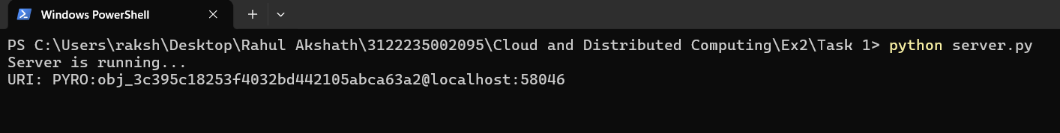
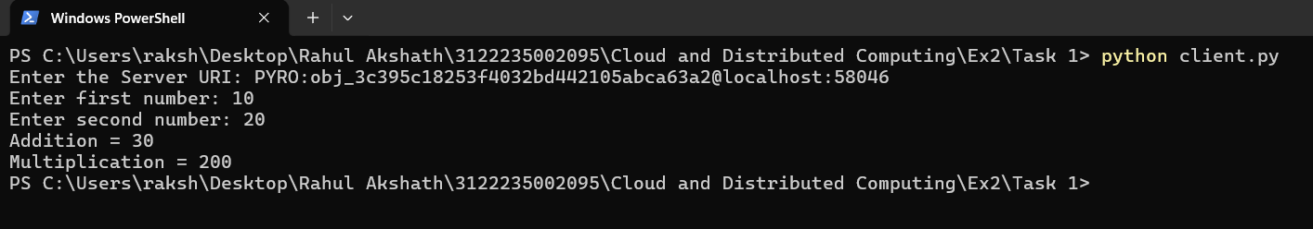
Exercise 2 - Google Cloud Console
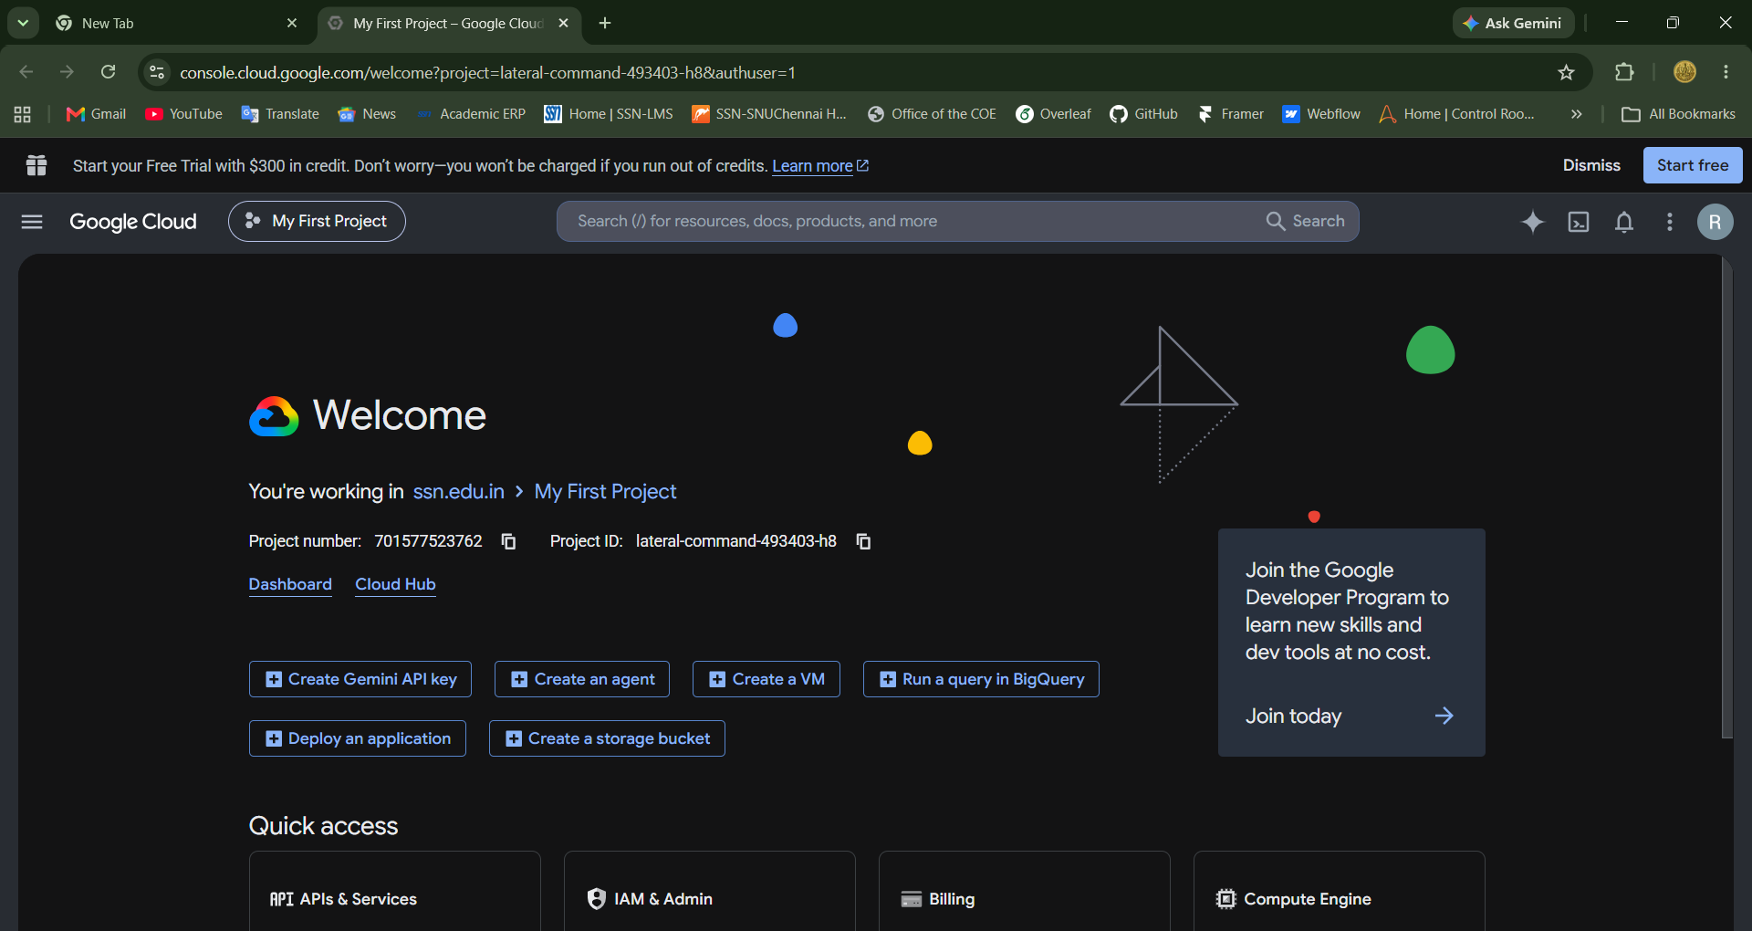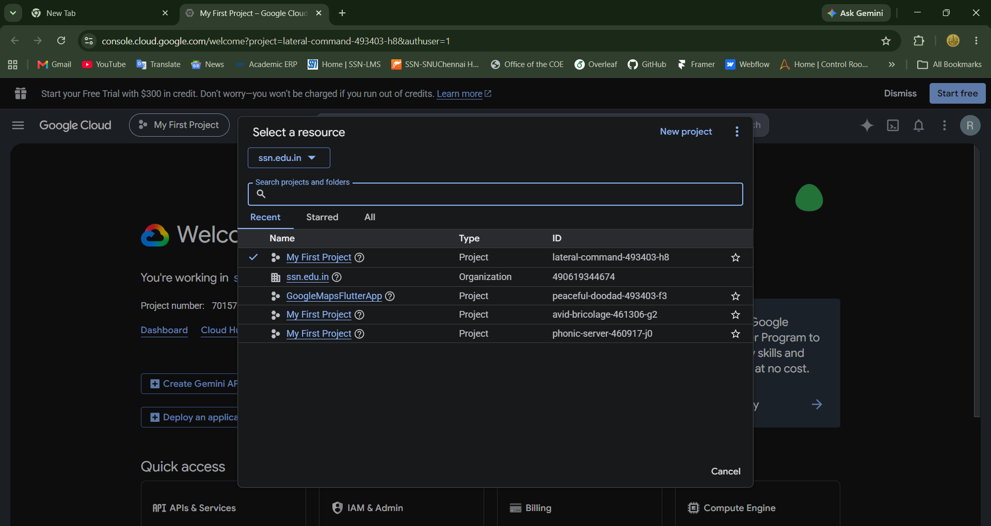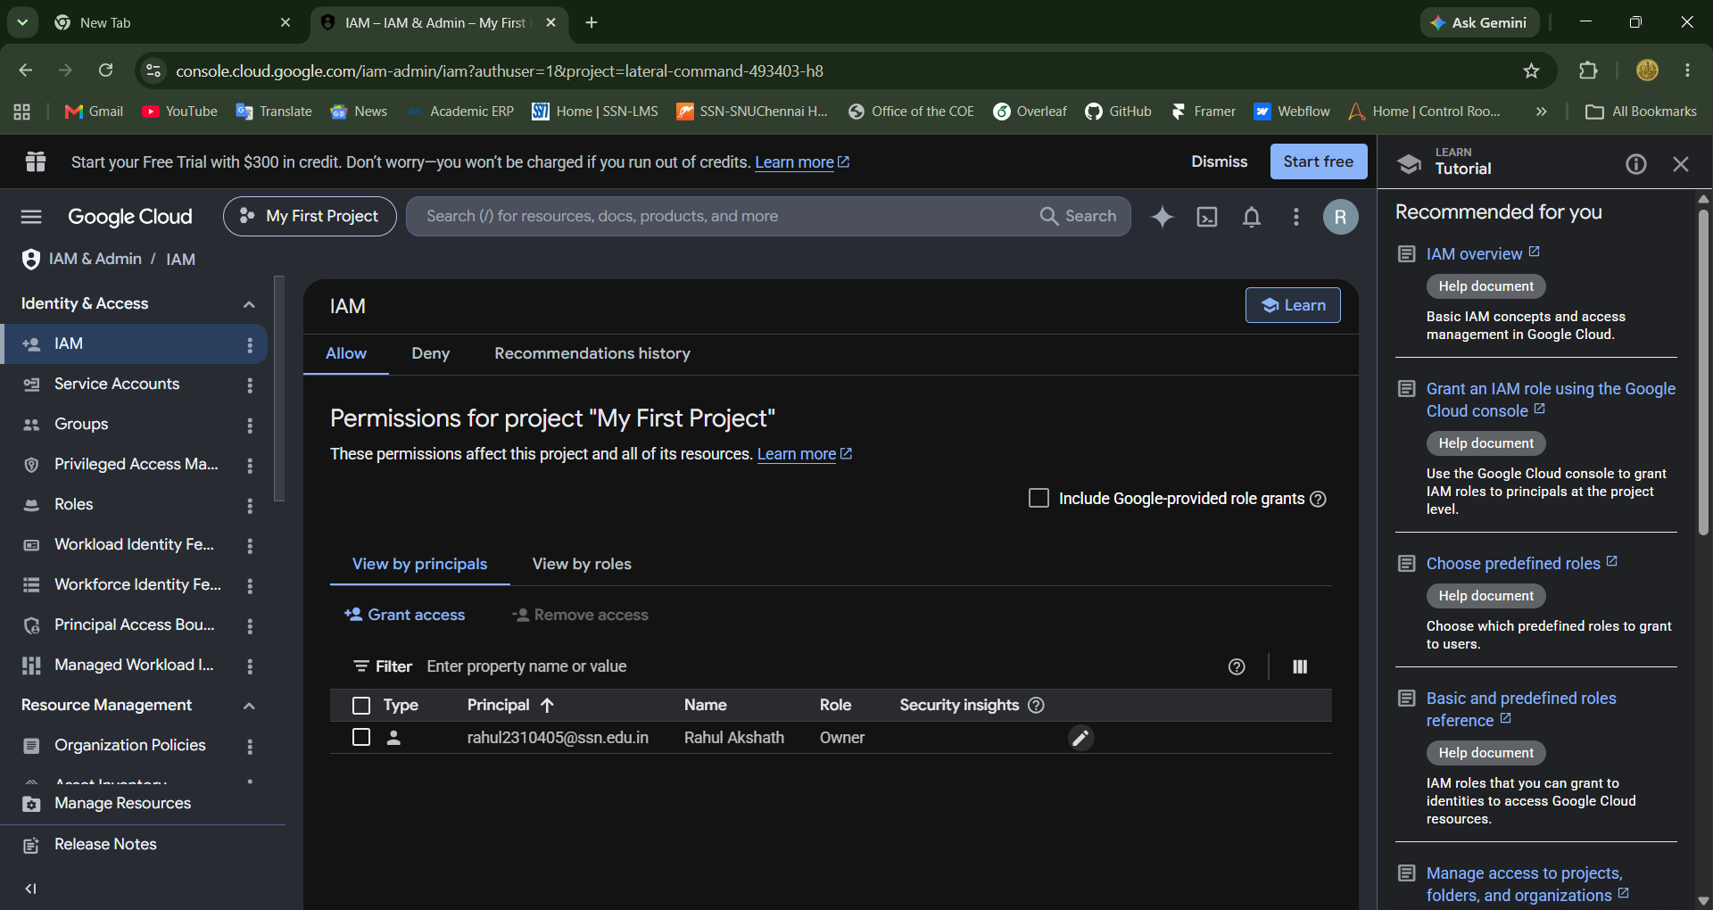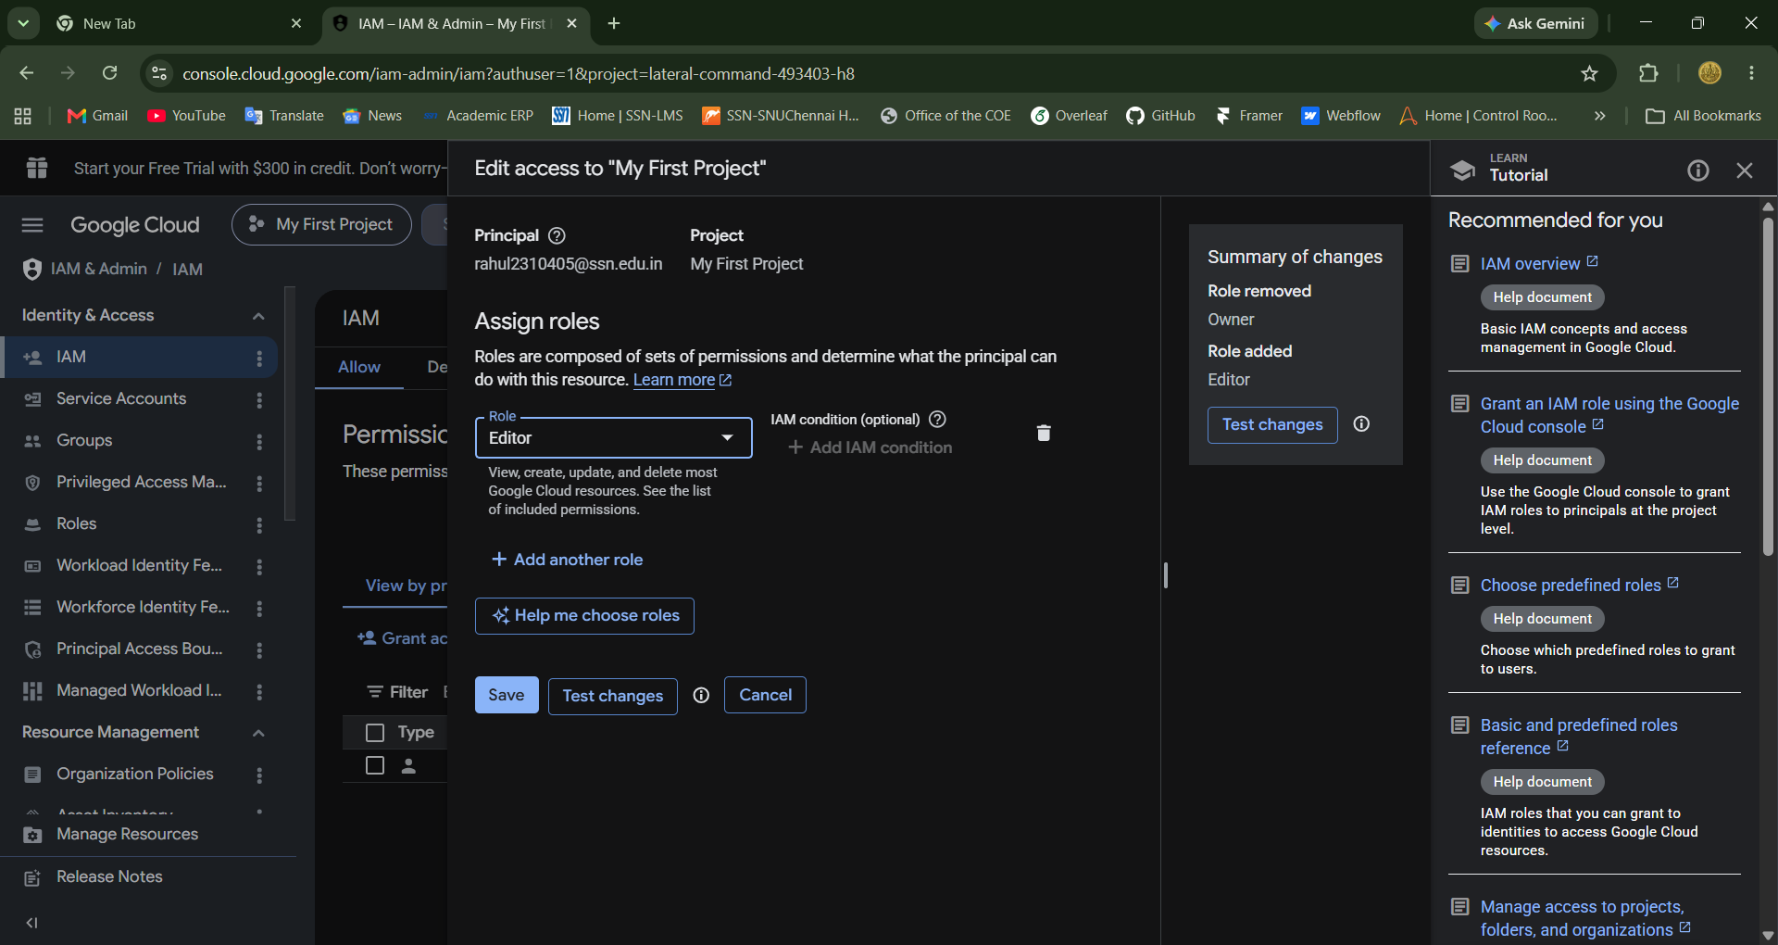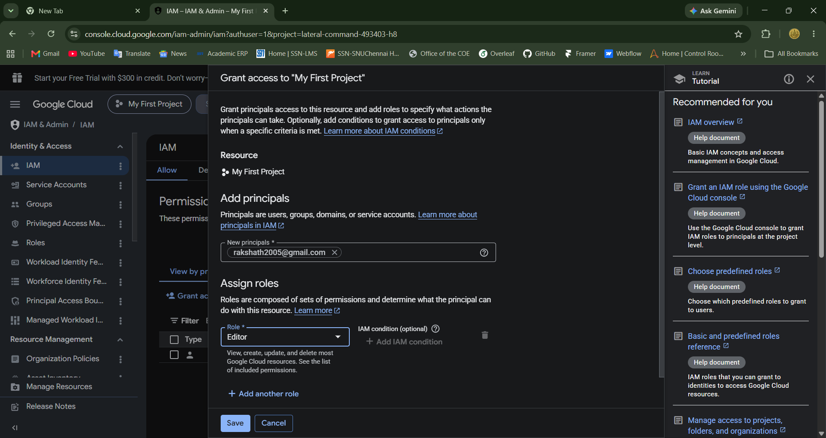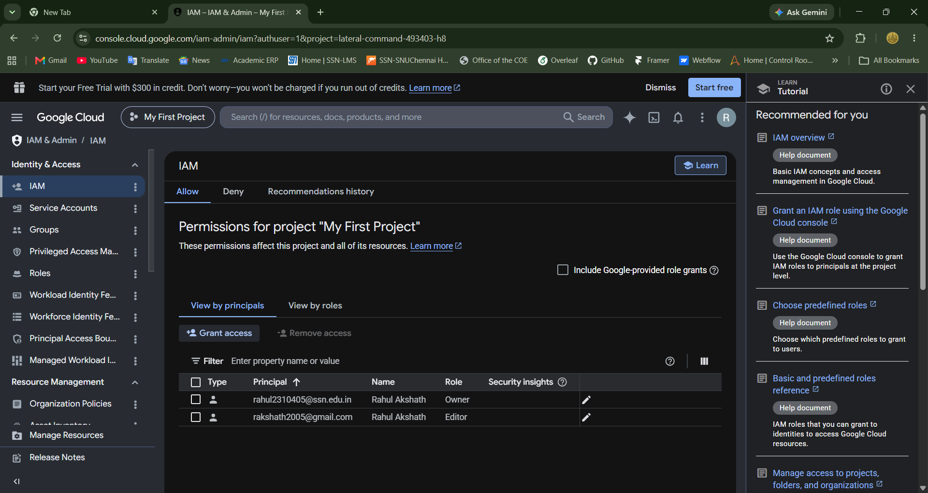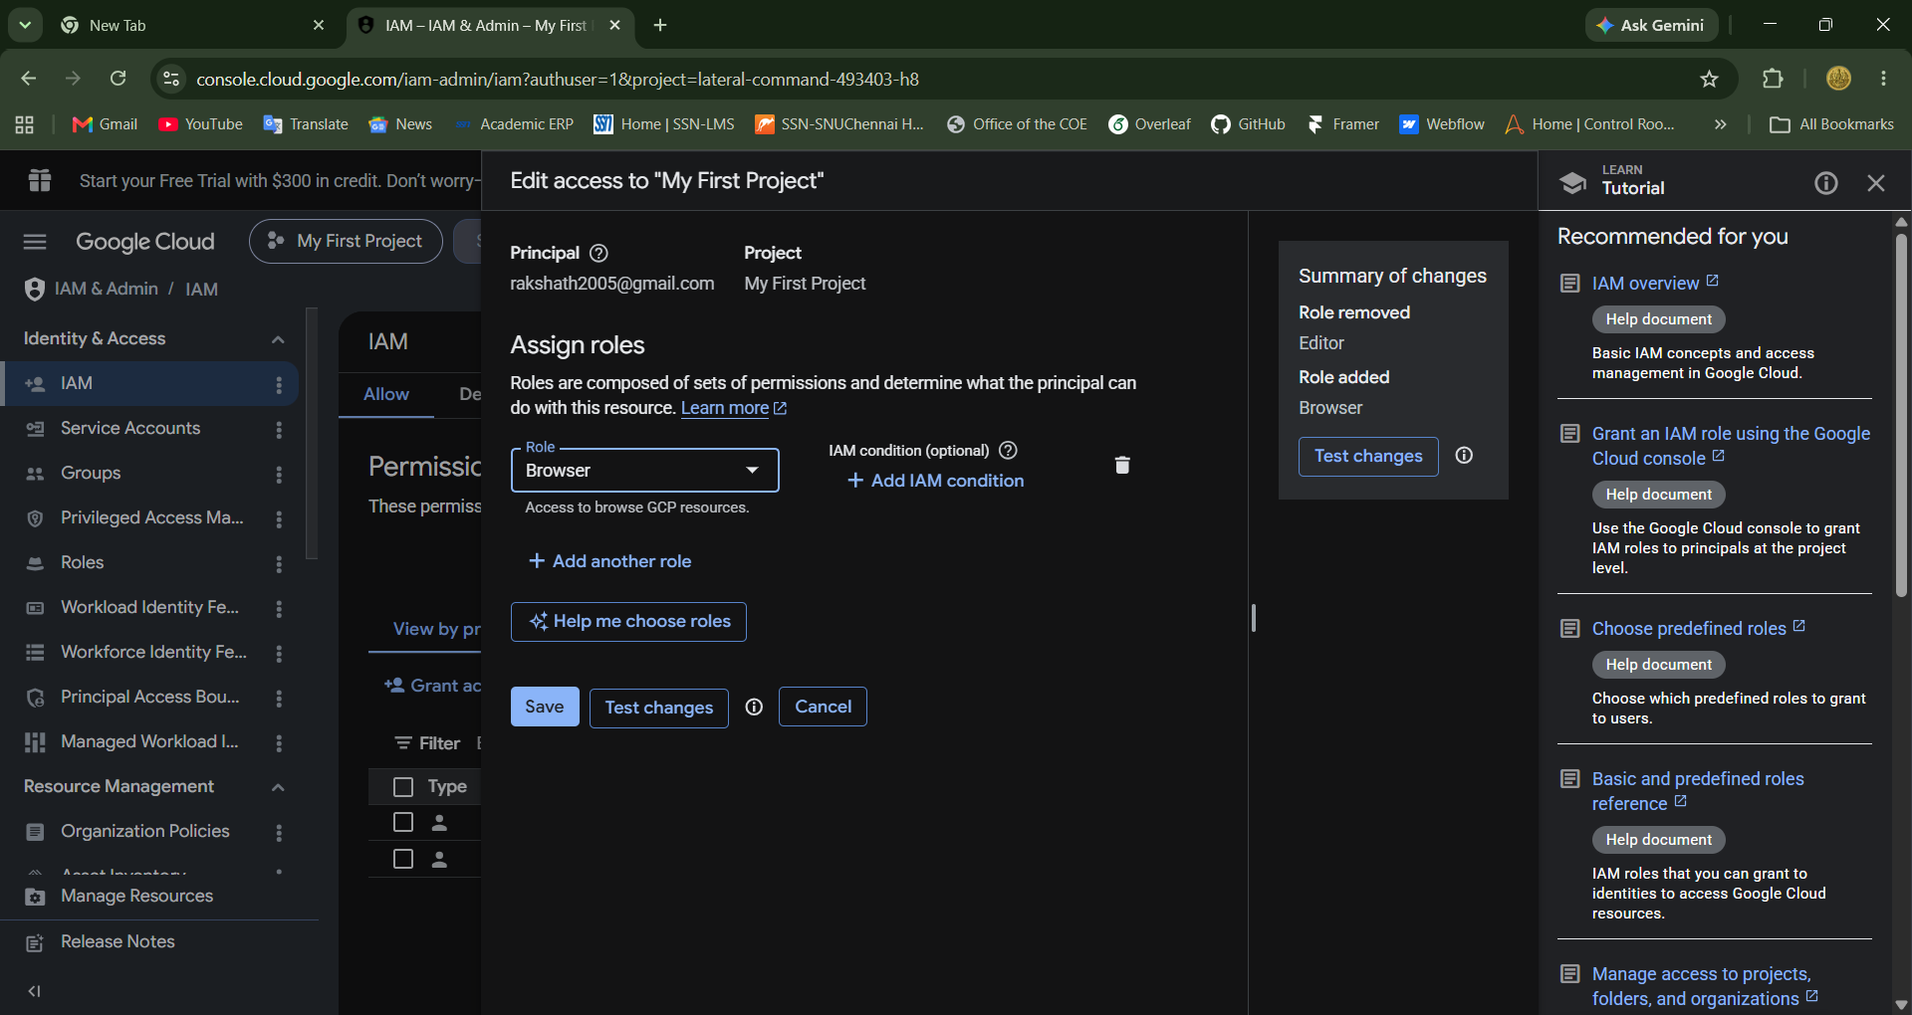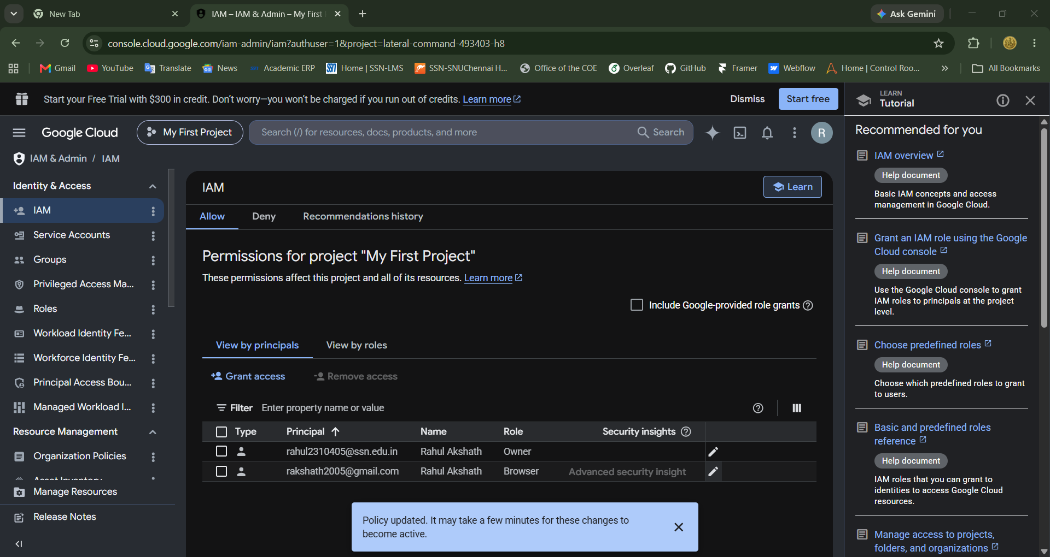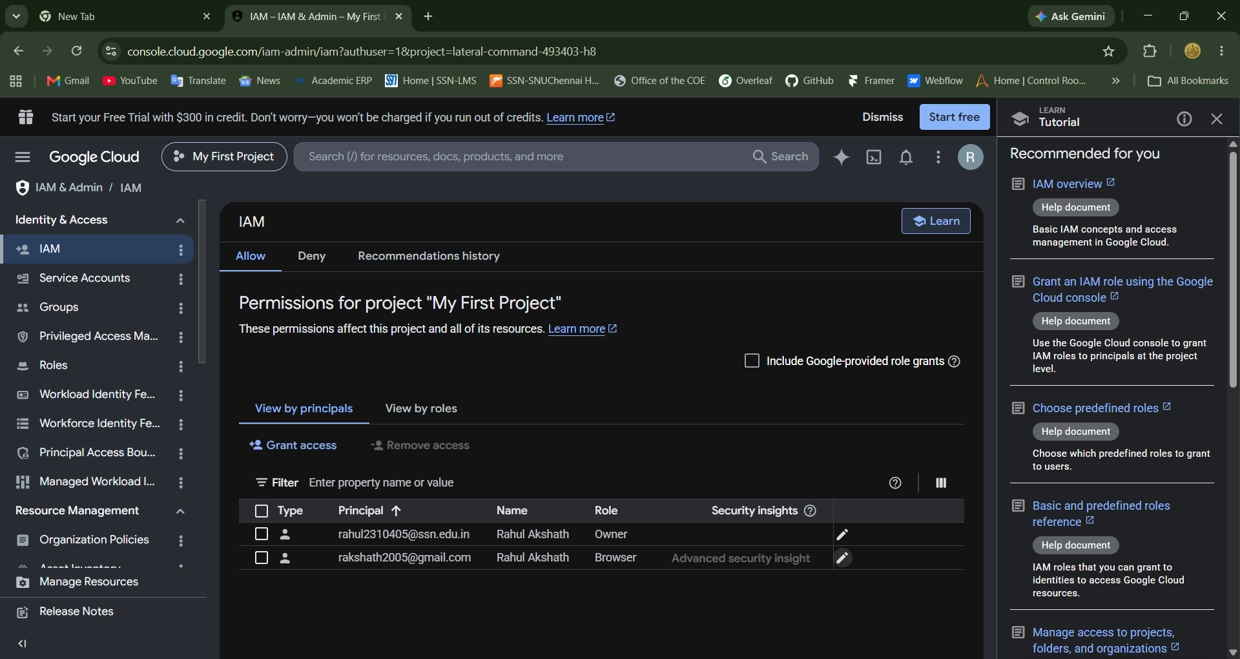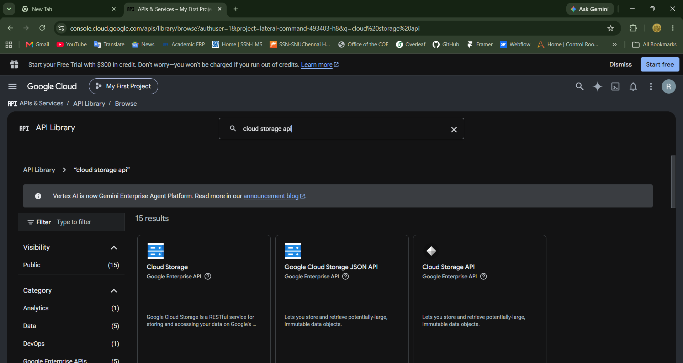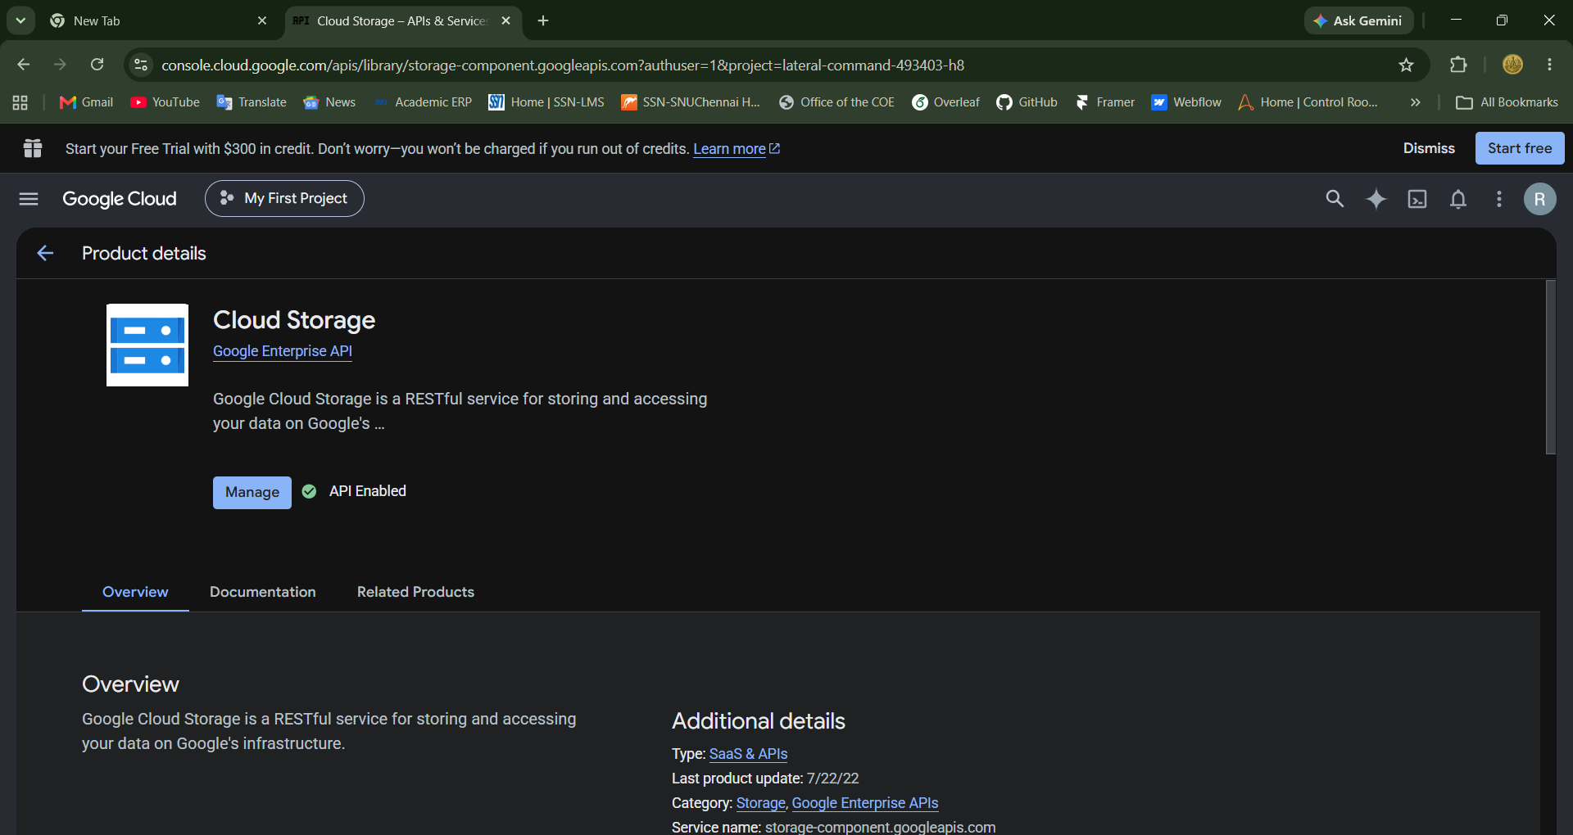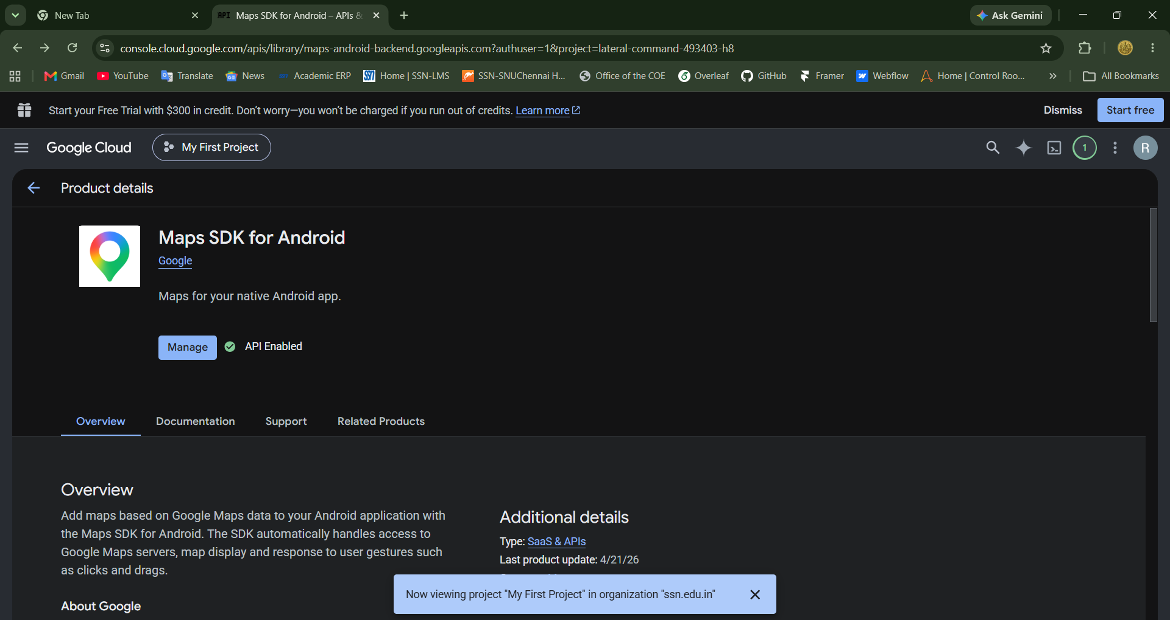

CONCLUSION
Remote Method Invocation was implemented successfully using the Pyro4 library. The Calculator object was created and registered on the server, the daemon generated a unique URI for it, and the client used a proxy created from that URI to invoke the addition and multiplication methods as if they were local. This demonstrates how location transparency is achieved in distributed systems, where the marshalling of arguments, the network transfer and the unmarshalling of results are all handled by the middleware. In the second part, the Google Cloud Console was explored: projects were viewed and identified, IAM roles and permissions were reviewed and modified, and APIs were enabled from the API library. Thus both the programming model of remote invocation and the basic administration of a public cloud platform were understood.

